SRINIVAS UNIVERSITY
COLLEGE OF PHYSIOTHERAPY
Mangalore-575001, Karnataka (India)

Research Centre for Pediatric sciences and Rehabilitation

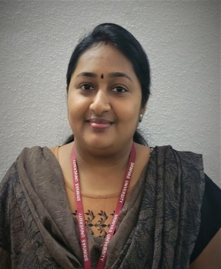
Dr. RADHIKA GOPAL. S (PT)

The research center for pediatric sciences and research works for research on a variety of physical, mental illness and social issues related to the pediatric population. Counseling is fundamentally associated with pediatric research. Current Pediatric Research is an interdisciplinary Research approach for publication of original research work in all major disciplines of Pediatric Research. Research trials focus on restoring the movements and improving the overall functional activity of the child focusing on reducing or preventing level of disability and thereby designed for the uplifting the mankind.

OBJECTIVES

- The objective of this research centre is to provide a scientific communication medium to discuss the utmost advancements in the domain of Pediatric Research.
- To provide an excellent clinical experience in the management of pediatric patients of all ages with a broad spectrum of illnesses and injuries.
- To train students in the immediate recognition and treatment of life threatening illnesses including medical, surgical, and psychiatric emergencies.
- To train students in the recognition, evaluation and management of pediatric physical disabilities.
- Providing sophisticated treatment approaches based on scientific basis for prevention and treatment of functional impairments and disability.
- To provide students with the skills necessary to meet the emotional needs of patients, their families, and in the Pediatric Department.
- To facilitate good working relationships with colleagues and consultants.
- To provide experience in teaching and supervising residents and students rotating in the pediatric department,
- To provide opportunities for physiotherapists to acquire skills in oral presentation, medical writing, and research design.
- To develop an understanding of the administrative aspects pediatric department.

PROJECTS COMPLETED:
- Prevalence of sensory processing disorder among school going children in North Eastern India
- Correlation between excessive screen time and sensory processing disorder in typically developing children –a cross sectional study.
- Effectiveness of yoga in addition to physiotherapy to improve attention and functional impairment in children with Cerebral Palsy: A randomised clinical trial
- Individual age specific normative data and reference equation of incremental shuttle walk test in healthy children age d between 5-12 years.

ONGOING PROJECTS:
- Impact of Covid -19 pandemic on movement and play behaviour in school aged children and adolescents of Mangalore: A survey

****

